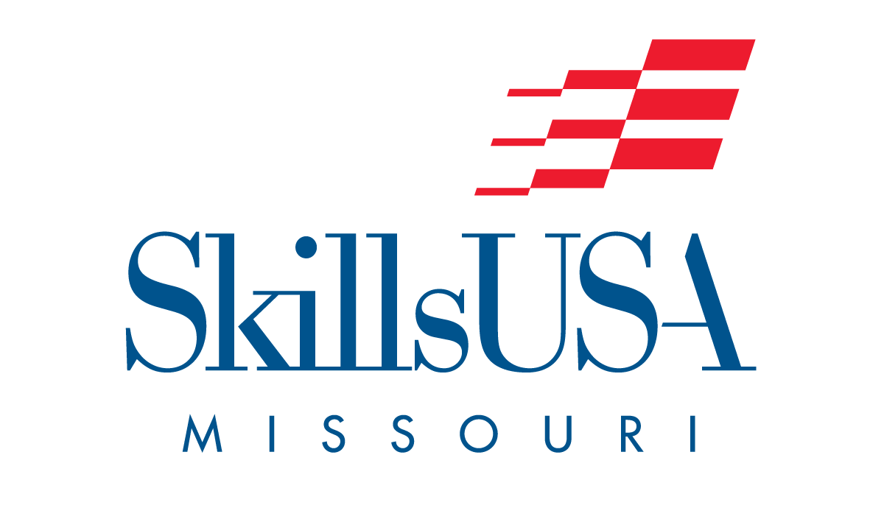

**Missouri SkillsUSA Chapter Assurance Form**

The Missouri SkillsUSA Members of ______________________________ Chapter from ___________________________ School District, along with their parents/guardians, have read and completed the 202___ - 202___ Personal Liability and Medical Release Form. The Personal Liability and Medical Release Form was received by the SkillsUSA local chapter advisor and will be kept on file at the school district. The SkillsUSA local chapter advisor will carry a copy of this form with him/her at all SkillsUSA Missouri events.

Local chapter advisors are directly responsible for the student supervision.

_____________________­__________ ________________________ ____________

Chapter advisor name printed Chapter advisor signature Date

_____________________­__________ ________________________ ____________

School administrator name printed School administrator signature Date

This form is to be submitted annually. Receipt of the Assurance Form will be checked for registered events. (For example: EMPOWER, SPARK, SLSC, etc.)

***The local chapter advisor will continually update their records to assure each student has a “Personal Liability and Medical Release Form” on file***

***Do not send individual forms to the state. Individual forms must be in possession of the local chapter advisor.***

[**UPLOAD HERE**](https://mofbla.wufoo.com/forms/skillsusa-2425-assurance-form-upload/)